**MAIN IDEA:**

If students don’t understand the difficulty of living a comfortable lifestyle while working a minimum wage job, there will be continued complacency in students taking their college education less seriously

**@Alexander** (Introduction):  
  
**Alex Python Coding/Analysis:**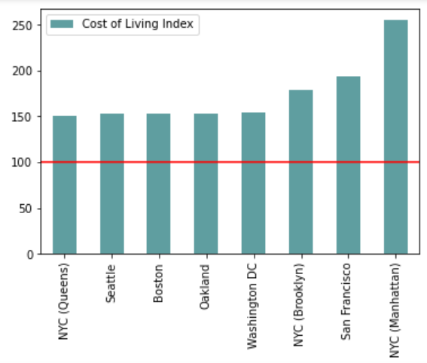

Graph 1 Code:

*import matplotlib.pyplot as plt*

*import numpy as np*

*import pandas as pd*

*my_array = (150.9, 152.7, 153.2, 153.4, 153.9, 178.8, 194.1, 255)*

*df = pd.DataFrame(my_array,*

*index=['NYC (Queens)', 'Seattle', 'Boston', 'Oakland', 'Washington DC', 'NYC*

*(Brooklyn)', 'San Francisco', 'NYC (Manhattan)'],*

*columns=pd.Index(['Cost of Living Index']))*

*ax = df.plot.bar(color ='#5F9EA0')*

*ax.hlines(y=100, xmin=-1, xmax=20, color='#EE3B3B')*

Graph 1 Analysis:

This is a graph displaying the cost of living index in 8 out of the top 10 most expensive cities to live in the United States. The red line is set at 100, this number came out to be the average of the 267 urban areas in the US. As you can see all of these cities are above the national average index showing that living in urban areas is more expensive than the average in other parts of the country.

**Source**: <https://www.coli.org/annual-average-2021-cost-of-living-index-released/>

This is the national cost of living index in the United States. This document takes into account 267 urban areas in the United States and sets that average at 100 to compare the other major cities to the average. I have used the list that took the top 10 cities in the country that are the most expensive places to live in the country. Along with another list that takes the cheapest urban areas in the US.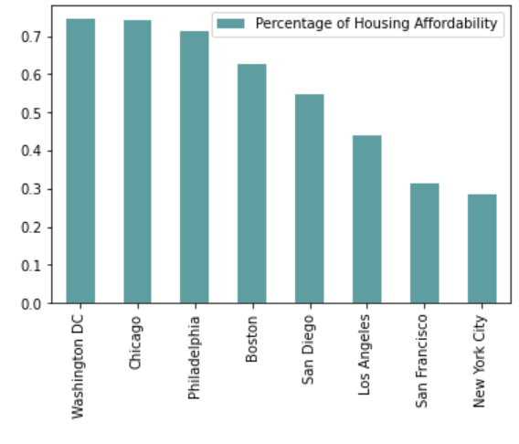

Graph 2 Code:

*my_array3 = (.745, .743, .713, .625, .546, .441, .314, .285)*

*df3 = pd.DataFrame(my_array3,*

*index=['Washington DC', 'Chicago', 'Philadelphia', 'Boston', 'San Diego', 'Los*

*Angeles', 'San Francisco', 'New York City'],*

*columns=pd.Index(['Percentage of Housing Affordability']))*

*df3.plot.bar(color = '#5F9EA0')*

Graph 2 Analysis:

This graph shows the housing affordability percentage of some of the major cities in the United States. This means that the higher the percentage, the more affordable the city is. Therefore, New York and San Francisco are the least affordable cities to find housing in, making it even harder to stay afloat in these cities.

**Source:** <https://www.granitecity.illinois.gov/departments/economic_development/facts_and_figures/cost_of_living.php>

This source also compares major cities in the United States against the national average. In addition, this source displays the most expensive places for housing in the United States. As discussed before, San Francisco and New York City are the most expensive places to live in the country because they have a lower housing affordability percentage.

**@Prakriti** (Enrollment stats):

**Prakriti Python Coding/Analysis:**

Graph 1 Analysis:

The graph represents the number of students enrolled in post-secondary institutions, based on 5,908 institutions in the US. It reflects a downward shift in the number of students enrolled over 10 years period of time.

**Source:** <https://nces.ed.gov/ipeds/TrendGenerator/app/answer/2/2>

This source shows the data collected from post-secondary institutions from 2001-to 2020. I used their data from 2010-2020 to reflect the shift in the number of students enrolled in the past 10 years.

Code:

*import matplotlib.pyplot as plt #imported all the libraries necessary*

*import matplotlib*

*import pandas as pd*

*#get the excel data file*

*df_student_enrollment= pd.read_excel('/Users/prakritiac/Downloads/CIS9655groupproject/students_enrollment.xlsx')*

*df_student_enrollment= df_student_enrollment[0:10]*

*df_student_enrollment= df_student_enrollment.sort_index(axis=0,ascending=False)*

*#create bar plot*

*df = pd.DataFrame(df_student_enrollment)*

*import matplotlib.ticker as tick*

*fig, ax = plt.subplots()*

*ax.yaxis.set_major_formatter(formatter) #set yaxis in millions*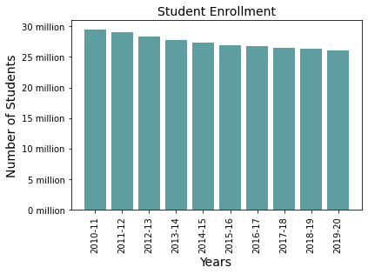

*X = list(df.iloc[:, 0])*

*Y = list(df.iloc[:, 1])*

*plt.bar(X, Y, color='#5F9EA0')*

*plt.title("Student Enrollment", fontsize=14)*

*plt.xlabel("Years", fontsize=14)*

*plt.ylabel("Number of Students", fontsize=14)*

*plt.xticks(rotation=90) #to eliminate the overlapping of numbers*

*plt.show()*

Graph 2 Analysis:

This graph indicates the number of US minimum wage workers by educational attainment in the year 2020. It shows the difference of having any sort of college education or degree can make in the salary as opposed to not having any educational background.

**Source:** <https://www.statista.com/statistics/299395/us-minimum-wage-workers-by-education/>

This statistic depicts the number of workers earning hourly rates at or below the current federal minimum wage in the United States in 2020, by educational attainment. I used the data provided to create a bar chart that reflects the importance of having a college degree.

Code:

*#get the excel data file*

*df_minimumwage_byedu=pd.read_excel('/Users/prakritiac/Downloads/CIS9655groupproject/number-of-us-minimum-wage-workers-by-education-2020.xlsx')*

*df_minimumwage_byedu*

*#create barplot*

*df = pd.DataFrame(df_minimumwage_byedu)*

*X = list(df.iloc[:, 1])*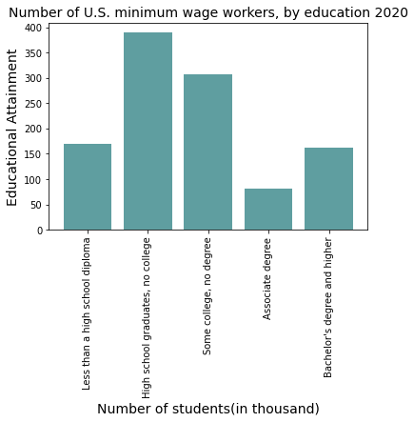

*Y = list(df.iloc[:, 0])*

*plt.bar(Y,X, color='#5F9EA0')*

*plt.title("Number of U.S. minimum wage workers, by education 2020", fontsize=14)*

*plt.ylabel("Educational Attainment", fontsize=14)*

*plt.xlabel("Number of students(in thousand)", fontsize=14)*

*plt.xticks(rotation=450) #to eliminate text overlapping*

*plt.show()*

**@Amanda** (Minimum wage across New York and inflation):

**Amanda Python Coding/Analysis:**

Graph 1 Analysis:

Graph 1 shows a map of New York state with the counties outlined. I wanted to show this graph so people could see the geography of New York State. Minimum wage in New York has different rates depending on which region you work in so I wanted anyone in the audience who is unfamiliar with New York state's geography to see where these regions are.

**Source:**

*The source for Graph 1 comes from the Python libraries used in the code*

Code:

*from bokeh.io import show*

*from bokeh.models import LogColorMapper*

*from bokeh.palettes import YlGnBu7 as palette*

*from bokeh.plotting import figure*

*from bokeh.sampledata.us_counties import data as counties*

*palette = tuple(reversed(palette))*

*counties = {*

*code: county for code, county in counties.items() if county["state"] == "ny"*

*}*

*county_xs = [county["lons"] for county in counties.values()]*

*county_ys = [county["lats"] for county in counties.values()]*

*county_names = [county['name'] for county in counties.values()]*

*color_mapper = LogColorMapper(palette=palette)*

*data=dict(*

*x=county_xs,*

*y=county_ys,*

*name=county_names,*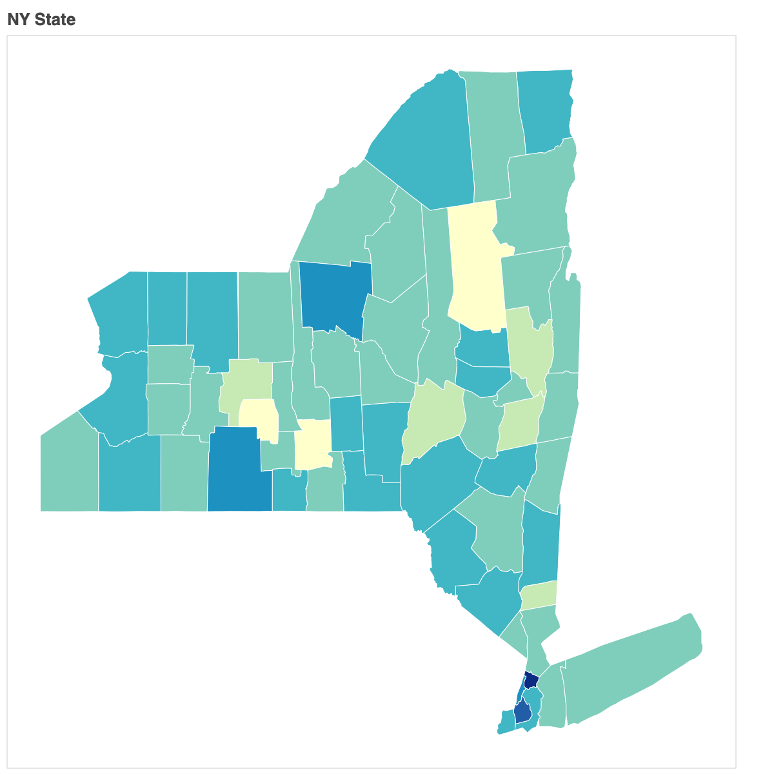

*rate=county_rates,*

*)*

*TOOLS = "pan,wheel_zoom,reset,hover,save"*

*p = figure(*

*title="NY State", tools=TOOLS,*

*x_axis_location=None, y_axis_location=None,*

*tooltips=[*

*("Name", "@name"), ("(Long, Lat)", "($x, $y)")*

*])*

*p.grid.grid_line_color = None*

*p.hover.point_policy = "follow_mouse"*

*p.patches('x', 'y', source=data,*

*fill_color={'field': 'rate', 'transform': color_mapper},*

*fill_alpha=1, line_color="white", line_width=0.5)*

*show(p)*

Graphs 2-5 Analysis:

*These four graphs come from the same source and the same Python data frame*

**Source for graphs 2-5:**

<https://www.ny.gov/new-york-states-minimum-wage/new-york-states-minimum-wage>

This source shows New York State’s minimum wage in different regions from 12/31/2016 up until 12/31/2021. I used this data to create a dataframe in Python so I could create line graphs for the minimum wage in each region since 2016.

Code for graphs 2-5 dataframe:

*import pandas as pd*

*import matplotlib.pyplot as plt*

*import numpy as np*

*nyregions=pd.DataFrame({*

*'NYC-Big Employers': [11.00, 13.00, 15.00, 15.00, 15.00, 15.00],*

*'NYC-Small Employers': [10.50, 12.00, 13.50, 15.00, 15.00, 15.00],*

*'Long Island & Westchester': [10.00, 11.00, 12.00, 13.00, 14.00, 15.00],*

*'Remainder of New York State': [9.70, 10.40, 11.10, 11.80, 12.50, 13.20]*

*}, index=[2016,2017,2018,2019,2020, 2021])*

**Graph 2:**

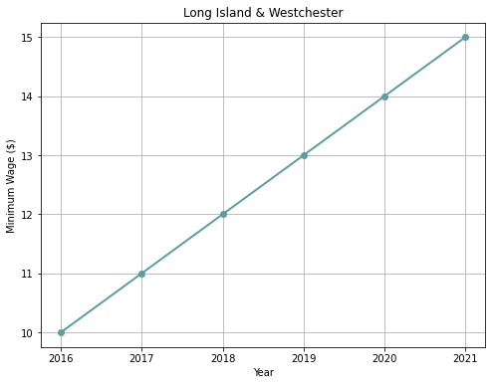

Analysis:

Graph 2 shows the minimum wage in Long Island and Westchester from December of 2016 up until December of 2021. We see that the minimum wage has consistently gone up by $1 every year since 2016.

Code:

*regionliw=nyregions['Long Island & Westchester'].plot.line(color="#5F9EA0", title="Long Island & Westchester", marker='o', xlabel="Year", ylabel="Minimum Wage ($)", linewidth=2, figsize=(8,6) )*

*ax=regionliw*

*ax.set_xticks([2016,2017,2018,2019,2020,2021])*

*ax.grid(True)*

**Graph 3:**

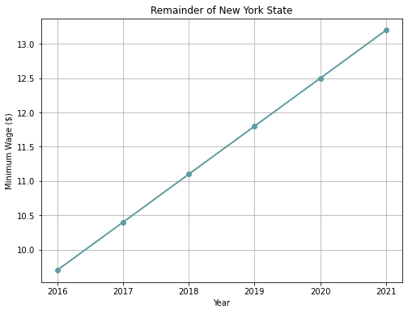

Analysis:

Graph 3 shows the minimum wage for the remainder of New York State (not Long Island or Westchester and not NYC) from December of 2016 up until December of 2021. We see that the minimum wage has consistently gone up 70¢ every year since 2016.

Code:

*regionros=nyregions['Remainder of New York State'].plot.line(color="#5F9EA0", title="Remainder of New York State", marker='o', xlabel="Year", ylabel="Minimum Wage ($)",linewidth=2, figsize=(8,6) )*

*ax=regionros*

*ax.set_xticks([2016,2017,2018,2019,2020, 2021])*

*ax.grid(True)*

**Graph 4:**

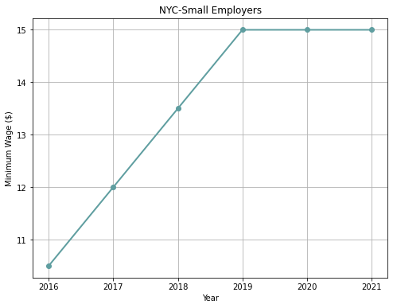

Analysis:

Graph 4 shows the minimum wage for the remainder of small employers in New York City from December of 2016 up until December of 2021. We see that the minimum wage has not increased since 2019 and has remained at $15.

Code:

*regionnycs=nyregions['NYC-Small Employers'].plot.line(color="#5F9EA0", title="NYC-Small Employers", marker='o', xlabel="Year", ylabel="Minimum Wage ($)", linewidth=2, figsize=(8,6))*

*ax=regionnycs*

*ax.set_xticks([2016,2017,2018,2019,2020, 2021])*

*ax.grid(True)*

**Graph 5:**

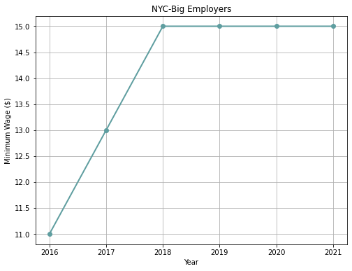

Analysis:

Graph 5 shows the minimum wage for the remainder of big employers in New York City from December of 2016 up until December of 2021. We see that the minimum wage has not increased since 2018 and has remained at $15.

Code:

*regionnycb=nyregions['NYC-Big Employers'].plot.line(color="#5F9EA0", title="NYC-Big Employers", marker='o', xlabel="Year", ylabel="Minimum Wage ($)", linewidth=2, figsize=(8,6))*

*ax=regionnycb*

*ax.set_xticks([2016,2017,2018,2019,2020, 2021])*

*ax.grid(True)*

Graph 6 Analysis:

Graph 6 shows inflation in the U.S. every month since 2016. This is important because we can see that inflation has gone up since 2016, but New York City’s minimum wage remains at $15. The inflation rate in 2021 reached over 7.0, but the minimum wage remains the same. The $15 minimum wage that people earn is worth less today than it was in previous years.

**Source:**

<https://www.usinflationcalculator.com/inflation/current-inflation-rates/>

This source shows U.S. inflation rates from 2000 to 2022. I used this data to create a dataframe in Python so I could create a line graph showing inflation in the U.S. I only used data from 2016 till 2022 so that it would be the same years of the minimum wage graphs I created earlier.

Code:

*inflation=pd.DataFrame({*

*'Inflation': [1.4, 1.0, 0.9, 1.1, 1.0, 1.0, 0.8, 1.1, 1.5, 1.6, 1.7, 2.1, 2.5, 2.7, 2.4, 2.2, 1.9, 1.6, 1.7, 1.9, 2.2, 2.0, 2.2, 2.1, 2.1, 2.2, 2.4, 2.5, 2.8, 2.9, 2.9, 2.7, 2.3, 2.5, 2.2, 1.9, 1.6, 1.5, 1.9, 2.0, 1.8, 1.6, 1.8, 1.7, 1.7, 1.8, 2.1, 2.3, 2.5, 2.3, 1.5, 0.3, 0.1, 0.6, 1.0, 1.3, 1.4, 1.2, 1.2, 1.4, 1.4, 1.7, 2.6, 4.2, 5.0, 5.4, 5.4, 5.3, 5.4, 6.2, 6.8, 7.0, 7.5]*

*}, index=['Jan 2016', 'Feb 2016', 'Mar 2016', 'Apr 2016', 'May 2016', 'Jun 2016', 'Jul 2016', 'Aug 2016', 'Sep 2016', 'Oct 2016', 'Nov 2016', 'Dec 2016', 'Jan 2017', 'Feb 2017', 'Mar 2017', 'Apr 2017', 'May 2017', 'Jun 2017', 'Jul 2017', 'Aug 2017', 'Sep 2017', 'Oct 2017', 'Nov 2017', 'Dec 2017', 'Jan 2018', 'Feb 2018', 'Mar 2018', 'Apr 2018', 'May 2018', 'Jun 2018', 'Jul 2018', 'Aug 2018', 'Sep 2018', 'Oct 2018', 'Nov 2018', 'Dec 2018', 'Jan 2019', 'Feb 2019', 'Mar 2019', 'Apr 2019', 'May 2019', 'Jun 2019', 'Jul 2019', 'Aug 2019', 'Sep 2019', 'Oct 2019', 'Nov 2019', 'Dec 2019', 'Jan 2020', 'Feb 2020', 'Mar 2020', 'Apr 2020', 'May 2020', 'Jun 2020', 'Jul 2020', 'Aug 2020', 'Sep 2020', 'Oct 2020', 'Nov 2020', 'Dec 2020', 'Jan 2021', 'Feb 2021', 'Mar 2021', 'Apr 2021', 'May 2021', 'Jun 2021', 'Jul 2021', 'Aug 2021', 'Sep 2021', 'Oct 2021', 'Nov 2021', 'Dec 2021', 'Jan 2022'])*

*inflationnums=inflation.plot.line()*

*inflationnums=inflation.plot.line(color="#5F9EA0", title="Inflation in the U.S. since 2016", xlabel="Year", ylabel="Inflation Rates", legend=None, linewidth=2, figsize=(8,6))*

*plt.locator_params(axis="x", nbins=6)*

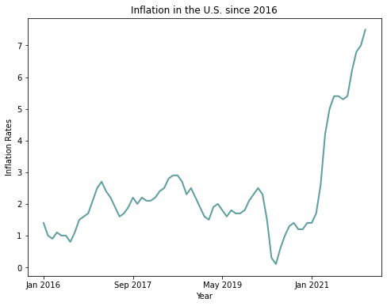

**@Paulina** (Spending Calculator):

**Paulina Python Coding/Analysis:**

*from bokeh.plotting import figure, show*

*from bokeh.models import ColumnDataSource, Label, LabelSet*

*#collecting input*

*wage_hourly = float(input("Enter minimum wage per hour in USD: "))*

*wage_yearly = wage_hourly * 52 * 40*

*print("Total annual budget: ",wage_yearly,"\n")*

*total_spending = 0*

*while total_spending <= wage_yearly:*

*spending_data = {"Rent":0,"Utilities":0,"Groceries":0,"Transportation":0,"Leisure":0,*

*"Clothing":0,"Restaurants":0,"DEBT":0}*

*rent = float(input("Insert monthly rent in USD: ")) * 12*

*total_spending += rent*

*if wage_yearly - total_spending >= 0:*

*spending_data["Rent"] = rent*

*print("We got housing, we have ", wage_yearly - total_spending," USD left.\n")*

*else:*

*debt = total_spending - wage_yearly*

*spending_data["DEBT"] = debt*

*spending_data["Rent"] = rent - debt*

*break*

*utilities = float(input("Insert monthly utilities in USD: ")) * 12*

*total_spending += utilities*

*if wage_yearly - total_spending >= 0:*

*spending_data["Utilities"] = utilities*

*print("We got utilities, we have ", wage_yearly - total_spending," USD left.\n")*

*else:*

*debt = total_spending - wage_yearly*

*spending_data["DEBT"] = debt*

*spending_data["Utilities"] = utilities - debt*

*break*

*groceries = float(input("Insert monthly groceries in USD: ")) * 12*

*total_spending += groceries*

*if wage_yearly - total_spending >= 0:*

*spending_data["Groceries"] = groceries*

*print("We got groceries, we have ", wage_yearly - total_spending," USD left.\n")*

*else:*

*debt = total_spending - wage_yearly*

*spending_data["DEBT"] = debt*

*spending_data["Groceries"] = groceries - debt*

*break*

*transportation = float(input("Insert monthly transportation in USD: ")) * 12*

*total_spending += transportation*

*if wage_yearly - total_spending >= 0:*

*spending_data["Transportation"] = transportation*

*print("We got transportation, we have ", wage_yearly - total_spending," USD left.\n")*

*else:*

*debt = total_spending - wage_yearly*

*spending_data["DEBT"] = debt*

*spending_data["Transportation"] = transportation - debt*

*break*

*leisure = float(input("Insert monthly leisure cost in USD: ")) * 12*

*total_spending += leisure*

*if wage_yearly - total_spending >= 0:*

*spending_data["Leisure"] = leisure*

*print("We got leisure, we have ", wage_yearly - total_spending," USD left.\n")*

*else:*

*debt = total_spending - wage_yearly*

*spending_data["DEBT"] = debt*

*spending_data["Leisure"] = leisure - debt*

*break*

*clothing = float(input("Insert monthly clothing cost in USD: ")) * 12*

*total_spending += clothing*

*if wage_yearly - total_spending >= 0:*

*spending_data["Clothing"] = clothing*

*print("We got clothing, we have ", wage_yearly - total_spending," USD left.\n")*

*else:*

*debt = total_spending - wage_yearly*

*spending_data["DEBT"] = debt*

*spending_data["Clothing"] = clothing - debt*

*break*

*restaurants = float(input("Insert monthly dining-out cost in USD: ")) * 12*

*total_spending += restaurants*

*if wage_yearly - total_spending >= 0:*

*spending_data["Restaurants"] = restaurants*

*print("We got dining, we have ", wage_yearly - total_spending," USD left.\n")*

*break*

*else:*

*debt = total_spending - wage_yearly*

*spending_data["DEBT"] = debt*

*spending_data["Restaurants"] = restaurants - debt*

*break*

*print(spending_data)*

*#vizual*

*bars = ['Minimum wage per year', 'Total annual spending']*

*colors = ["#A2CD5A", "#BBFFFF","#98F5FF","#8EE5EE","#7AC5CD","#5F9EA0","#53868B","#2F4F4F","#EE3B3B"]*

*if spending_data["DEBT"] == 0:*

*stacks = ["Minimum wage","Rent", "Utilities", "Groceries","Transportation",*

*"Leisure", "Clothing", "Restaurants"]*

*pattern = "/"*

*data = {"data" : bars,*

*"Minimum wage" : [int(wage_yearly),0],*

*"Rent" : [0,spending_data["Rent"]], in*

*"Utilities" : [0,spending_data["Utilities"]],*

*"Groceries" : [0,spending_data["Groceries"]],*

*"Transportation" : [0,spending_data["Transportation"]],*

*"Leisure" : [0,spending_data["Leisure"]],*

*"Clothing" : [0,spending_data["Clothing"]],*

*"Restaurants" : [0,spending_data["Restaurants"]]}*

*used_stacks = stacks*

*taken_colors = colors[0:len(used_stacks)]*

*taken_patterns = pattern*

*else:*

*pattern = ["/", "/", "/", "/", "/","/","/","/","x"]*

*data = {'data' : bars}*

*used_stacks = list()*

*used_stacks.append("Minimum wage")*

*data["Minimum wage"] = [wage_yearly,0]*

*for k,v in spending_data.items():*

*if v != 0:*

*used_stacks.append(k)*

*data[k] = [0,v]*

*taken_colors = []*

*idx = 0*

*for item in used_stacks:*

*if item == "DEBT":*

*taken_colors.append(colors[-1])*

*else:*

*taken_colors.append(colors[idx])*

*idx += 1*

*taken_patterns = []*

*idx = 0*

*for item in used_stacks:*

*if item == "DEBT":*

*taken_patterns.append(pattern[-1])*

*else:*

*taken_patterns.append(pattern[idx])*

*idx += 1*

*p = figure(x_range = bars, height = 500, title = "Can you live on the minimum wage?",*

*toolbar_location = "right", tools = "pan,reset,save", tooltips = "$name: @$name USD")*

*p.vbar_stack(used_stacks, x = "data", width = 0.9, source = data,*

*color = taken_colors,*

*fill_alpha = 0.8,*

*hatch_pattern = taken_patterns, hatch_scale = 9, legend_label = used_stacks, line_alpha = 0.0)*

*#axis*

*p.y_range.start = 0*

*p.x_range.range_padding = 0.1*

*p.xgrid.grid_line_color = None*

*p.axis.minor_tick_line_color = None*

*p.outline_line_color = None*

*p.title.text_font_size = "20px"*

*p.yaxis.axis_label = 'Annual amounts in USD'*

*p.yaxis.axis_label_text_font = "helvetica"*

*p.yaxis.axis_label_text_font_size = "11px"*

*p.yaxis.axis_label_text_font_style = "normal"*

*#legend*

*p.legend.location = "top_right"*

*p.legend.orientation = "vertical"*

*p.legend.title_text_font_size = "5px"*

*#code for you need to work additional ... h to pay off the debt*

*if spending_data["DEBT"] > 0 :*

*sentence = " You will need to work about " + str("{0:.0f}".format(debt / 22.5)) + " extra hours to make that up! "*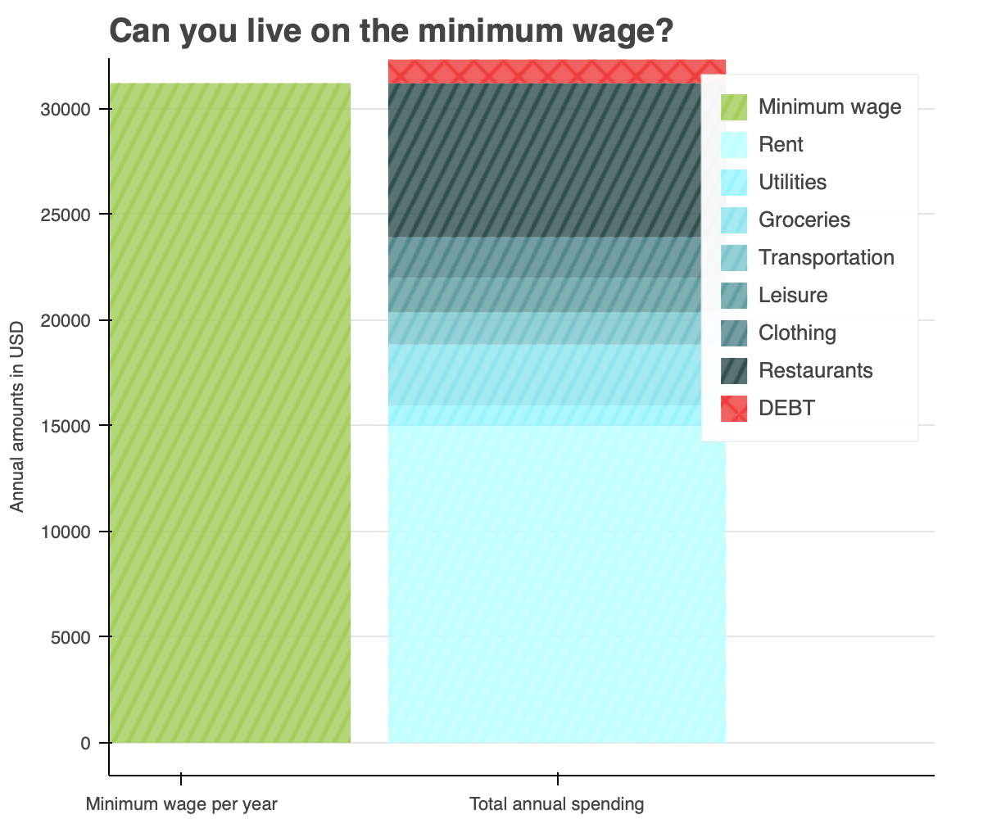

*citation = Label(x = 100, y = -100,x_units = 'screen', y_units = 'screen',*

*text = sentence, render_mode = 'css',*

*background_fill_color = 'white', background_fill_alpha = 1.0,*

*text_font = "helvetica", text_font_size = "15px")*

*p.add_layout(citation)*

*show(p)*

The code takes monthly input from the user and calculates annual excess spending; while having a constrained budget at our disposal (15 USD per hour in NYC). The code accepts the following input categories: rent, utilities, groceries, transportation, leisure, clothing, and restaurants (dining out). The outcome of the code is a graph. The graph consists of two bars, the first one (green) is our annual budget and the other (blue) presents all spending categories input by the user. In case spending exceeds the budget, the excess is marked in red.

The visual helps to capture hardships of life on minimum pay even after being extremely cautious about the spending.

**Source:** own work; inspired by New York Times article: <https://www.nytimes.com/interactive/2014/02/09/opinion/minimum-wage.html?searchResultPosition=1&fbclid=IwAR136F0LUkCKCcMi9lQd0Z5jmYCNaPFkysH5MjLr-tN7VrS4hv5ZfgXqRLY&mtrref=l.facebook.com&gwh=A88E87E38C363F9E6C2AF0DD7F187D1F&gwt=pay&assetType=PAYWALL>

**@Andrew** (Summary):

**Andrew Coding/Analysis:**

*Age_Group = ['16-24','25-34','35-44','45-54','55-64','65+']*

*Number_of_workers_in_thousands = [529,250,130,93,75,35]*

*import matplotlib.pyplot as plt*

*colors_bar = ['#2F4F4F','#2F4F4F','#5F9EA0','#5F9EA0','#5F9EA0','#5F9EA0','#5F9EA0']*

*plt.bar(Age_Group,Number_of_workers_in_thousands,color=colors_bar)*

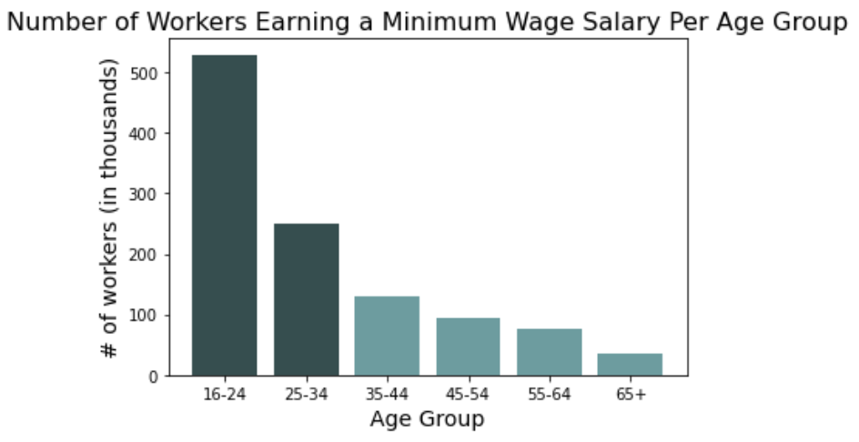

*plt.title('Number of Workers Earning a Minimum Wage Salary Per Age Group', fontsize=16)*

*plt.xlabel('Age Group', fontsize=14)*

*plt.ylabel('# of workers (in thousands)',fontsize=14)*

*plt.show()*

This graph depicts the number of individuals who are employed and receive minimum wage salaries in the United States in 2020 and is broken down by age. This chart helps develop the argument that a large majority of individuals who are younger do work these jobs. We want our audience to understand that taking your education seriously and using it as leverage will help you avoid the pressures of minimum wage financial struggles.

**Source:** <https://www.statista.com/statistics/298852/minimum-wage-workers-in-the-us-by-age/>

**Sources:**

* <https://www.coli.org/annual-average-2021-cost-of-living-index-released/>
* <https://www.granitecity.illinois.gov/departments/economic_development/facts_and_figures/cost_of_living.php>
* <https://nces.ed.gov/ipeds/TrendGenerator/app/answer/2/2>
* <https://www.statista.com/statistics/299395/us-minimum-wage-workers-by-education/>
* <https://www.statista.com/statistics/298852/minimum-wage-workers-in-the-us-by-age/>
* <https://www.ny.gov/new-york-states-minimum-wage/new-york-states-minimum-wage>
* <https://www.investopedia.com/terms/i/inflation.asp>
* <https://www.usinflationcalculator.com/inflation/current-inflation-rates/>
* <https://www.numbeo.com/cost-of-living/in/New-York>
* <https://www.nytimes.com/interactive/2014/02/09/opinion/minimum-wage.html?searchResultPosition=1&fbclid=IwAR136F0LUkCKCcMi9lQd0Z5jmYCNaPFkysH5MjLr-tN7VrS4hv5ZfgXqRLY&mtrref=l.facebook.com&gwh=A88E87E38C363F9E6C2AF0DD7F187D1F&gwt=pay&assetType=PAYWALL>